THE PERIODIC TABLE

The periodic table is an arrangement of all the elements known to man in accordance with their increasing atomic number and recurring chemical properties. They are assorted in a tabular arrangement wherein a row is a period and a column is a group.

Elements are arranged from left to right and top to bottom in the order of their increasing atomic numbers. Thus,

* Elements in the same group will have the same valence electron configuration and hence, similar chemical properties.
* Whereas, elements in the same period will have an increasing order of valence electrons. Therefore, as the energy level of the atom increases, the number of energy sub-levels per energy level increases.

The first 94 elements of the periodic table are naturally occurring, while the rest from 95 to 118 have only been synthesized in laboratories or nuclear reactors.

The [modern periodic table](https://byjus.com/chemistry/modern-periodic-table/), the one we use now, is a new and improved version of certain models put forth by scientists in the 19th and 20th century. Dimitri Mendeleev put forward his periodic table based on the findings of some scientists before him like John Newlands and Antoine-Laurent de Lavoisier. However, Mendeleev is given sole credit for his development of the periodic table.

## Why was Mendeleev Periodic Table widely accepted?

Dimitri Mendeleev, widely referred as the father of the periodic table put forth the first iteration of the periodic table similar to the one we use now. Mendeleev’s periodic law is different from the [modern periodic law](https://byjus.com/chemistry/modern-periodic-table-modern-periodic-law/) in one main aspect.

* Mendeleev modeled his periodic table on the basis of increasing atomic mass, whereas, the modern periodic law is based on the increasing order of atomic numbers.

Even though Mendeleev’s periodic table was based on atomic weight, he was able to predict the discovery and properties of certain elements. During his time only around half of the elements known to us now were known, and most of the information known about the elements were inaccurate. Mendeleev’s Periodic Table was published in the German Journal of chemistry in 1869.

# What is a group in a periodic table?

A group is a column of elements in the periodic table of the chemical elements. The elements in a group have similar physical or chemical characteristics of the outermost electron shells of their atoms.

**What are the first 20 elements of periodic table in order?**

* H – Hydrogen
* He – Helium
* Li – Lithium
* Be – Beryllium
* B – Boron
* C – Carbon
* N – Nitrogen
* O – Oxygen
* F – Fluorine
* Ne – Neon
* Na – Sodium
* Mg – Magnesium
* Al – Aluminium
* Si – Silicon
* P – Phosphorus
* S – Sulphur
* Cl – Chlorine
* Ar – Argon
* K – Potassium
* Ca – Calcium

What is modern periodic table explain?

The modern or long form of the periodic table is based on the modern periodic law. The table is the arrangement of elements in increasing order of their atomic numbers.

|  |  |  |
| --- | --- | --- |
| **Name of the Element** | **Symbol of the Element** | **Atomic Number** |
| [Hydrogen](https://byjus.com/chemistry/hydrogen/) | H | 1 |
| [Helium](https://byjus.com/chemistry/helium/) | He | 2 |
| [Lithium](https://byjus.com/chemistry/lithium/) | Li | 3 |
| [Beryllium](https://byjus.com/chemistry/beryllium/) | Be | 4 |
| [Boron](https://byjus.com/chemistry/boron/) | B | 5 |
| [Carbon](https://byjus.com/chemistry/carbon/) | C | 6 |
| [Nitrogen](https://byjus.com/chemistry/nitrogen/) | N | 7 |
| [Oxygen](https://byjus.com/chemistry/oxygen/) | O | 8 |
| [Fluorine](https://byjus.com/chemistry/fluorine/) | F | 9 |
| [Neon](https://byjus.com/chemistry/neon/) | Ne | 10 |
| [Sodium](https://byjus.com/chemistry/sodium/) | Na | 11 |
| [Magnesium](https://byjus.com/chemistry/magnesium/) | Mg | 12 |
| [Aluminium](https://byjus.com/chemistry/aluminum/) | Al | 13 |
| [Silicon](https://byjus.com/chemistry/silicon/) | Si | 14 |
| [Phosphorus](https://byjus.com/chemistry/phosphorus/) | P | 15 |
| [Sulfur](https://byjus.com/chemistry/sulfur/) | S | 16 |
| [Chlorine](https://byjus.com/chemistry/chlorine/) | Cl | 17 |
| [Argon](https://byjus.com/chemistry/argon/) | Ar | 18 |
| [Potassium](https://byjus.com/chemistry/potassium/) | K | 19 |
| [Calcium](https://byjus.com/chemistry/calcium/) | Ca | 20 |

What is the atomic number?

The atomic number of an atom is equivalent to the total number of electrons present in a neutral atom or the total number of protons present in the nucleus of an atom.

What is an element?

An element is a substance that can not be decomposed into simpler substances by ordinary chemical processes. It is the fundamental unit of the matter.

## Valency

The combining capacity of an atom is known as its valency. The number of bonds that an atom can form as part of a compound is expressed by the valency of the element.

We all know how electrons in an atom are arranged in shells/orbitals. [***Valence electrons***](https://byjus.com/chemistry/valence-electrons/)***are those electrons which are present in the outermost orbit of the atom.*** From the Bohr-bury scheme, we can say that the outermost shell can contain a maximum of 8 electrons. Only a little chemical activity is observed when the outermost shell is completely filled. We can also say that it’s combining capacity becomes zero.

For example, nitrogen forms a number of compounds with hydrogen such as NH3, N2H4, N3H in which [nitrogen atoms](https://byjus.com/chemistry/nitrogen/) have valencies of 3, 2 and 1/3 respectively. Thus, this concept of valency as a mere number was not clear. Therefore, later on valency was defined as the number of chemical bonds formed by an atom in a molecule

[Noble gases](https://byjus.com/chemistry/uses-and-applications-of-the-noble-gases/) have a completely filled outermost shell and that’s why they are least reactive. Other element’s reactivity depends upon their ability to attain the noble gas configuration. In this section, we shall learn more about the valency of an atom.

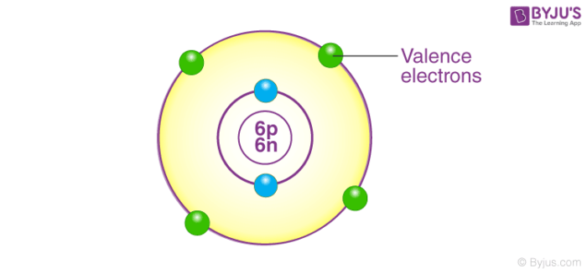

If the outermost shell has 8 electrons then the element is said to have a complete octet. By gaining, sharing and losing the electrons the atoms complete their outermost orbital and make an octet.

The capacity of an atom is described by the total number of electrons lost, gained or shared to complete its octet and it also determines the valency of the atom.

## How to Find Valency of Elements?

As we know, the number of electrons in the outermost shell of hydrogen is 1, and in [magnesium,](https://byjus.com/chemistry/magnesium/)it is 2. Therefore, the valency of hydrogen is 1 as it can easily lose 1 electron and become stable. On the other hand, that of magnesium is 2 as it can lose 2 electrons easily and also attain stability.

Furthermore, it is not only determined when an atom loses an electron. For example, fluorine has 7 electrons in its outermost orbital. It is hard to lose 7 electrons and so it completes its octet by gaining 1 electron. Since it gains 1 electron, its valency is 1. In the [periodic table](https://byjus.com/periodic-table/), the elements in the same group have the same valency.

For example, all the elements in group 8 have 8 electrons and completely filled orbitals, that is why the valency of all the elements in this group is zero.

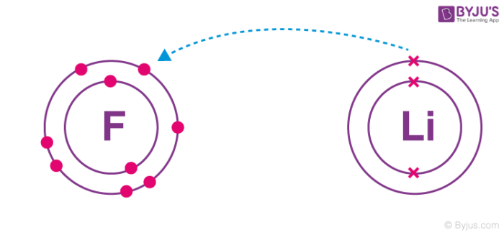

## Difference between Valency and Oxidation Number

Valency is different from the oxidation number, and it has ***NO SIGN***. Thus, the valency of nitrogen is 3, whereas it can have oxidation numbers from -3 to +5. The [oxidation number](https://byjus.com/chemistry/how-to-calculate-oxidation-number/) is the hypothetical charge of an atom in a molecule or ion, and it is a measure of its apparent capacity to gain or lose electrons within that species.

## Valency of First 30 Elements

Let us look at the valency of the first 30 elements of the periodic table.

|  |  |  |
| --- | --- | --- |
| **Element** | **Atomic Number** | **Valency** |
| **Valency of Hydrogen** | **1** | **1** |
| **Valency of Helium** | **2** | **0** |
| **Valency of Lithium** | **3** | **1** |
| **Valency of Beryllium** | **4** | **2** |
| **Valency of Boron** | **5** | **3** |
| **Valency of Carbon** | **6** | **4** |
| **Valency of Nitrogen** | **7** | **3** |
| **Valency of Oxygen** | **8** | **2** |
| **Valency of Fluorine** | **9** | **1** |
| **Valency of Neon** | **10** | **0** |
| **Valency of Sodium (Na)** | **11** | **1** |
| **Valency of Magnesium (Mg)** | **12** | **2** |
| **Valency of Aluminium** | **13** | **3** |
| **Valency of Silicon** | **14** | **4** |
| **Valency of Phosphorus** | **15** | **3** |
| **Valency of Sulphur** | **16** | **2** |
| **Valency of Chlorine** | **17** | **1** |
| **Valency of Argon** | **18** | **0** |
| **Valency of Potassium (K)** | **19** | **1** |
| **Valency of Calcium** | **20** | **2** |
| **Valency of Scandium** | **21** | **3** |
| **Valency of Titanium** | **22** | **4** |
| **Valency of Vanadium** | **23** | **5,4** |
| **Valency of Chromium** | **24** | **2** |
| **Valency of Manganese** | **25** | **7, 4, 2** |
| **Valency of Iron (Fe)** | **26** | **2, 3** |
| **Valency of Nickel** | **27** | **3, 2** |
| **Valency of Cobalt** | **28** | **2** |
| **Valency of Copper (Cu)** | **29** | **2, 1** |
| **Valency of Zinc** | **30** | **2** |

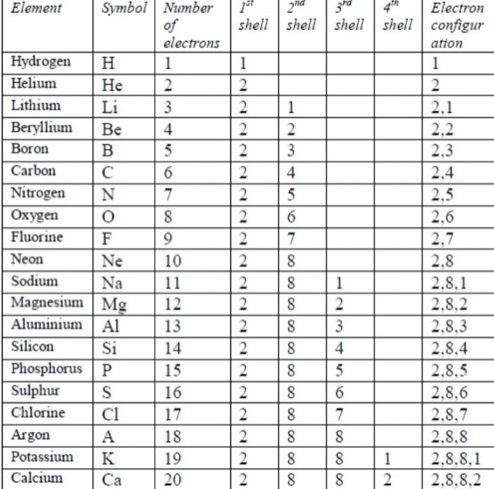

***Atoms and Molecules***

Atoms are much too small to be seen; hence experiments to find out their structure and behavior have to be conducted with large numbers of them. From the results of these experiments we may attempt to construct a hypothetical model of an atom that behaves like the true atom.

Molecules consist of one or more atoms bound together by covalent (chemical) bonds. Atoms may be depicted by circle shapes, each of which has a nucleus at the center (containing protons and neutrons), surrounded by one or more concentric circles representing the ‘shells’ or ‘levels’ in which the electrons surrounding the nucleus of the atom are located and markings indicating the electron.at each level. A molecule is the smallest thing a substance can be divided into while remaining the same substance. It is made up of two or more atoms that are bound together by chemical bonding.

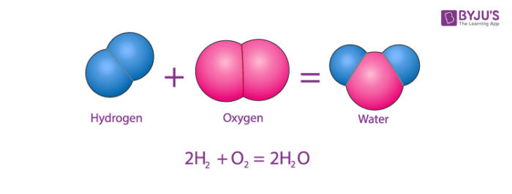

Atoms and Molecules

## Atom Definition Chemistry

The smallest particle of an element, which may or may not have an independent existence but always takes place in a chemical reaction is called an atom. An atom is defined as the smallest unit that retains the properties of an element. An atom is composed of sub-atomic particles and these cannot be made or destroyed. All atoms of the same element are identical and different elements have different types of atoms. Chemical reactions occur when atoms are rearranged.

Atoms consist of three fundamental types of particles, protons, electrons and neutrons. Neutrons and protons have approximately the same mass and in contrast to this the mass of an electron is negligible. A proton carries a positive charge, a neutron has no charge and an electron is negatively charged. An atom contains equal numbers of [protons](https://byjus.com/chemistry/protons/) and electrons and therefore overall an atom has no charge. The nucleus of an atom contains protons and neutrons only, and therefore is positively charged. The electrons occupy the region of space around the nucleus. Therefore, most of the mass is concentrated within the nucleus.

The center of the atom is called the nucleus. The nucleus contains neutrons and protons that give an atom its weight and positive charges. A neutron carries no charge and has a mass of one unit. A proton carries a single positive charge and also has a mass of one unit, The atomic number of an element is equal to the number of protons or positive charges in the nucleus. The atomic weight of an element is determined by combining the total number of protons and neutrons in the nucleus. An electron carries a single negative charge. If an atom of an element is to have zero charge, it must have the same number of electrons as protons. These electrons are arranged in orbits around the nucleus of the atom like the layers of an anion.

## What are Atoms made of?

An atom is composed of three particles, namely,  ***neutrons, protons and electrons*** with hydrogen as an exception without neutrons.

* Every atom has a nucleus that bounds one or more electrons around it.
* The nucleus has typically a similar number of protons and neutrons which are together known as nucleons.
* The protons are positively charged, electrons are negatively charged and neutrons are neutral.

## What is Atomic Mass?

It is the mass of an atom in a chemical element. It is roughly equivalent to the total [neutrons and protons](https://byjus.com/chemistry/proton-neutron-discovery/) present in the atom. It is expressed in atomic mass units (denoted by u). 1amu is equal to the exactly one-twelfth of the mass of 1 atom of C-12 and the relative atomic masses of elements is determined with respect to-12 atom.

### What are protons and neutrons?

Protons and neutrons are subatomic particles that make up the center of the atom, or its atomic nucleus.

* A **proton** is positively [charged](https://www.techtarget.com/whatis/definition/charge-electric-charge). The number of protons in the nucleus of an atom is the atomic number for the chemical element. Different elements' atomic numbers are found in the Periodic Table of Elements. For example, sodium has 11 protons, and its atomic number is 11
* A **neutron** is electrically neutral PARTICLE

The mass of a proton or neutron increases when the particle attains extreme speed, for example in a cyclotron or linear accelerator.

### The structure of an atom

The total mass of an atom, including the protons, neutrons and electrons, is the atomic mass or atomic weight. The atomic mass or weight is measured in [atomic mass units](https://www.techtarget.com/whatis/definition/atomic-mass-unit-AMU-or-amu).

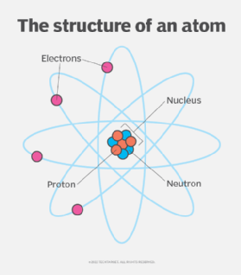

Electrons contribute only a tiny part to the mass of the atomic structure, however, they play an important role in the chemical reactions that create [molecules](https://www.techtarget.com/whatis/definition/molecule). For most purposes, the atomic weight can be thought of as the number of protons plus the number of neutrons. Because the number of neutrons in an atom can vary, there can be several different atomic weights for most elements.

Protons and electrons have equal and opposite charges. Protons have a positive charge and electrons a negative charge. Normally, atoms have equal numbers of protons and electrons, giving them a neutral charge.

An [ion](https://www.techtarget.com/whatis/definition/ion) is an atom with a different number of electrons than protons and is electrically charged. An ion with extra electrons has a negative charge and is called an anion and an ion deficient in electrons has a positive charge and is called a cation.

Atoms having the same number of protons but different numbers of neutrons represent the same element and are known as [isotopes](https://www.energy.gov/science/doe-explainsisotopes) of that element. An isotope for an element is specified by the sum of the number of protons and neutrons. For example, the following are two isotopes of the carbon atom:

* Carbon 12 is the most common, non-radioactive isotope of carbon.
* Carbon 14 is a less common, radioactive carbon isotope.

The only neutral atom with no neutrons is the hydrogen atom. It has one electron and one proton.

Molecule Definition

A molecule is defined as the smallest unit of a compound that contains the chemical properties of the compound.

Molecules are made up of groups of atoms. Describing the structure of an atom, an atom is also sub-divided into smaller units. Protons, electrons, and neutrons are sub-particles of an atom. The protons and neutrons are contained inside the nucleus of the atom and electrons revolve around the nucleus.

Protons are positively charged particles whereas electrons are negatively charged particles. Neutrons do not carry any charge. So we can say that the nucleus is positively charged due to the presence of protons. The nucleus is a bulk mass at the centre of an atom. Atoms are largely vacant.

Every element has a certain atomic number. The atomic number of an element is defined as the number of protons present in its nucleus. It is denoted by Z.

When we talk about the mass of atoms, the mass of their particles is taken into consideration. Electrons have negligible mass. Hence the mass of an atom is the sum of the mass of protons and neutrons. The mass number is denoted by A.

A molecule is the smallest unit (particle) of a compound having the physical and chemical properties of that compound. This does not mean that molecules can not be broken down into smaller parts, e.g. the atoms from which they are formed or the fragments of the molecule, each consisting of several atoms or parts of atoms.

A molecule is defined as the smallest unit of a compound that contains the chemical properties of the compound. Molecules are made up of groups of atoms. Describing the [structure of an atom](https://byjus.com/jee/atomic-structure/), an atom is also sub-divided into smaller units. Proton, electrons, and neutrons are sub-particles of an atom. The protons and neutrons are contained inside the nucleus of the atom and electrons revolve around the nucleus.

## Examples of Molecules

A molecule is a collection of two or more atoms that make up the smallest recognisable unit into which a pure material may be split while maintaining its makeup and chemical characteristics. Some examples of molecules are

* H2O (water)
* N2 (nitrogen)
* O3 (ozone)
* CaO (calcium oxide)
* C6H12O6 (glucose, a type of sugar)
* NaCl (table salt)

METALS

Metal does not actually have a solid definition since it is a broad term. However, they are usually described as substances with high electrical and thermal conductivity as well as malleability and lustre. Metals usually loses its electron to form positive ions known as cations.

[Metals](https://byjus.com/chemistry/metal/) form the largest group in the periodic table, and they are also defined according to their position in the periodic table. They are grouped as alkali metals, alkaline earth metals, transition metals, heavy metals and rare earth metals. On the basis of hardness, metals are also distinguished as used metals and non-metals. Usually, metals are extracted from their ores in the process called **refining**.

Form and structure

[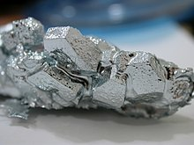](https://en.wikipedia.org/wiki/File:Gallium_crystals.jpg)

[Gallium](https://en.wikipedia.org/wiki/Gallium) crystals

Metals are shiny and [lustrous](https://en.wikipedia.org/wiki/Lustrous), at least when freshly prepared, polished, or fractured. Sheets of metal thicker than a few micrometres appear opaque, but [gold leaf](https://en.wikipedia.org/wiki/Gold_leaf) transmits green light.

The solid or liquid state of metals largely originates in the capacity of the metal atoms involved to readily lose their outer shell electrons. Broadly, the forces holding an individual atom's outer shell electrons in place are weaker than the attractive forces on the same electrons arising from interactions between the atoms in the solid or liquid metal. The electrons involved become delocalised and the atomic structure of a metal can effectively be visualised as a collection of atoms embedded in a cloud of relatively mobile electrons. This type of interaction is called a [metallic bond](https://en.wikipedia.org/wiki/Metallic_bond).[[6]](https://en.wikipedia.org/wiki/Metal#cite_note-morty-6) The strength of metallic bonds for different elemental metals reaches a maximum around the center of the [transition metal](https://en.wikipedia.org/wiki/Transition_metal) series, as these elements have large numbers of delocalized electrons.[[n 1]](https://en.wikipedia.org/wiki/Metal#cite_note-7)

Although most elemental metals have higher [densities](https://en.wikipedia.org/wiki/Density) than most [nonmetals](https://en.wikipedia.org/wiki/Nonmetal),[[6]](https://en.wikipedia.org/wiki/Metal#cite_note-morty-6) there is a wide variation in their densities, [lithium](https://en.wikipedia.org/wiki/Lithium) being the least dense (0.534 g/cm3) and [osmium](https://en.wikipedia.org/wiki/Osmium) (22.59 g/cm3) the most dense. (Some of the 6d transition metals are expected to be denser than osmium, but predictions on their densities vary widely in the literature, and in any case their known isotopes are too unstable for bulk production to be possible.) Magnesium, aluminium and titanium are [light metals](https://en.wikipedia.org/wiki/Light_metal) of significant commercial importance. Their respective densities of 1.7, 2.7, and 4.5 g/cm3 can be compared to those of the older structural metals, like iron at 7.9 and copper at 8.9 g/cm3. An iron ball would thus weigh about as much as three aluminum balls of equal volume.

[](https://en.wikipedia.org/wiki/File:Hot_metalwork.jpg)

A metal rod with a hot-worked eyelet. [Hot-working](https://en.wikipedia.org/wiki/Hot-working) exploits the capacity of metal to be plastically deformed.

Metals are typically malleable and ductile, deforming under stress without [cleaving](https://en.wikipedia.org/wiki/Cleavage_(crystal)).[[6]](https://en.wikipedia.org/wiki/Metal#cite_note-morty-6) The nondirectional nature of metallic bonding is thought to contribute significantly to the ductility of most metallic solids. In contrast, in an ionic compound like table salt, when the planes of an [ionic bond](https://en.wikipedia.org/wiki/Ionic_bond) slide past one another, the resultant change in location shifts ions of the same charge closer, resulting in the [cleavage](https://en.wikipedia.org/wiki/Cleavage_(crystal)) of the crystal. Such a shift is not observed in a [covalently bonded](https://en.wikipedia.org/wiki/Covalent_bond) crystal, such as a diamond, where fracture and crystal fragmentation occurs.[[7]](https://en.wikipedia.org/wiki/Metal#cite_note-8) Reversible [elastic deformation](https://en.wikipedia.org/wiki/Deformation_(engineering)) in metals can be described by [Hooke's Law](https://en.wikipedia.org/wiki/Hooke%27s_Law) for restoring forces, where the [stress](https://en.wikipedia.org/wiki/Stress_(mechanics)) is linearly proportional to the [strain](https://en.wikipedia.org/wiki/Deformation_(mechanics)).

Heat or forces larger than a metal's [elastic limit](https://en.wikipedia.org/wiki/Elastic_limit) may cause a permanent (irreversible) deformation, known as [plastic deformation](https://en.wikipedia.org/wiki/Plastic_deformation) or [plasticity](https://en.wikipedia.org/wiki/Plasticity_(physics)). An applied force may be a [tensile](https://en.wikipedia.org/wiki/Tensile_strength) (pulling) force, a [compressive](https://en.wikipedia.org/wiki/Compressive_strength) (pushing) force, or a [shear](https://en.wikipedia.org/wiki/Simple_shear), [bending](https://en.wikipedia.org/wiki/Bending), or [torsion](https://en.wikipedia.org/wiki/Torsion_(mechanics)) (twisting) force. A temperature change may affect the movement or displacement of [structural defects](https://en.wikipedia.org/wiki/Crystallographic_defect) in the metal such as [grain boundaries](https://en.wikipedia.org/wiki/Grain_boundaries), [point vacancies](https://en.wikipedia.org/wiki/Vacancy_defect), [line and screw dislocations](https://en.wikipedia.org/wiki/Dislocations), [stacking faults](https://en.wikipedia.org/wiki/Stacking_fault) and [twins](https://en.wikipedia.org/wiki/Crystal_twinning) in both [crystalline](https://en.wikipedia.org/wiki/Crystalline) and [non-crystalline](https://en.wikipedia.org/wiki/Amorphous_solid) metals. Internal [slip](https://en.wikipedia.org/wiki/Slip_(materials_science)), [creep](https://en.wikipedia.org/wiki/Creep_(deformation)), and [metal fatigue](https://en.wikipedia.org/wiki/Fatigue_(material)) may ensue.

Chemical

Metals are usually inclined to form [cations](https://en.wikipedia.org/wiki/Cations" \o "Cations) through electron loss.[[6]](https://en.wikipedia.org/wiki/Metal#cite_note-morty-6) Most will react with oxygen in the air to form [oxides](https://en.wikipedia.org/wiki/Oxide) over various timescales ([potassium](https://en.wikipedia.org/wiki/Potassium) burns in seconds while iron [rusts](https://en.wikipedia.org/wiki/Rust) over years). Some others, like [palladium](https://en.wikipedia.org/wiki/Palladium), [platinum](https://en.wikipedia.org/wiki/Platinum), and [gold](https://en.wikipedia.org/wiki/Gold), do not react with the atmosphere at all. The [oxides](https://en.wikipedia.org/wiki/Oxide) of metals are generally [basic](https://en.wikipedia.org/wiki/Base_(chemistry)), as opposed to those of [nonmetals](https://en.wikipedia.org/wiki/Nonmetal), which are [acidic](https://en.wikipedia.org/wiki/Acid) or neutral. Exceptions are largely oxides with very high [oxidation states](https://en.wikipedia.org/wiki/Oxidation_state) such as CrO3, Mn2O7, and OsO4, which have strictly acidic reactions.

[Painting](https://en.wikipedia.org/wiki/Painting), [anodizing](https://en.wikipedia.org/wiki/Anodizing), or [plating](https://en.wikipedia.org/wiki/Plating) metals are good ways to prevent their [corrosion](https://en.wikipedia.org/wiki/Corrosion). However, a more reactive metal in the [electrochemical series](https://en.wikipedia.org/wiki/Electrochemical_series) must be chosen for coating, especially when chipping of the coating is expected. Water and the two metals form an [electrochemical cell](https://en.wikipedia.org/wiki/Electrochemical_cell) and, if the coating is less reactive than the underlying metal, the coating actually *promotes* corrosion

Alloys

[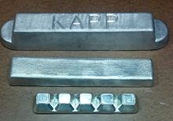](https://en.wikipedia.org/wiki/File:Pigs_and_Bars_of_Babbitt.jpg)

Samples of [babbitt metal](https://en.wikipedia.org/wiki/Babbitt_(alloy)" \o "Babbitt (alloy)), an alloy of [tin](https://en.wikipedia.org/wiki/Tin), [antimony](https://en.wikipedia.org/wiki/Antimony), and [copper](https://en.wikipedia.org/wiki/Copper), used in bearings to reduce friction

An alloy is a substance having metallic properties and which is composed of two or more [elements](https://en.wikipedia.org/wiki/Chemical_element) at least one of which is a metal. An alloy may have a variable or fixed composition. For example, gold and silver form an alloy in which the proportions of gold or silver can be freely adjusted; titanium and silicon form an alloy

### Uses

Different uses of Metals

Metals are usually very strong, most durable and highly resistant to everyday wear and tear. As such, they have been used since ancient times for a lot of things. And even today with advances in technology and a lot of other things the uses of metals have broadened greatly. Metals even play a key role in the economy. Let’s look at some important and popular metal uses.

* In the Construction Industry
* In electronics
* In medicine
* Machinery, Refractory and Automobiles
* Decorative products
* Other Uses

In the Construction Industry

Metals are the main component in the construction industry. Metals like iron, steel amongst others are the main materials used in the construction of buildings and even homes.

**In Electronics**

Another important application of metals are in electronics. As metals are good conductors of electricity, they are used to make wires and parts for equipments and gadgets that function on electrical current. Popular examples include TV, mobiles, fridge, iron, computers etc.

In medicine

If you are wondering how, well from a biological perspective metals are found as micro-elements in our bodies. Besides, the presence of metal elements is crucial for several functions like transmission of nerve impulses, oxygen flow, reaction between enzymes etc. Some medicines are therefore liaised with metal compounds to treat certain deficiencies or sickness. Metals like [iron](https://byjus.com/chemistry/iron/), calcium, magnesium, potassium, titanium and aluminium are used commonly in medicine in the form of antacids.

Apart from this, most of the equipments and tools used are made from metals.

Machinery, Refractory and Automobiles

This is one of the most common use of metals. They are used extensively in manufacturing machines for industries, agriculture or farming and automobiles which include road vehicles, railways, aeroplanes, rockets etc. Here, the commonly used metals are iron, aluminium and steel.

Besides these, most of the utensils that are used in the kitchen are made from metals like steel, aluminium, and copper. Due to a high temperature withstanding nature metals are preferred the most.

Decorative products

Metals such as platinum, gold, and silver come under the category of precious metals and have high economical value. These metals are widely used in making jewellery sets or for some decorative pieces.

Other Uses of Metals

Some other uses and applications of metals are, that they play an important role in security as the metals are used in making locks, strong safe, doors etc. Apart from this, furnitures are made from metal these days. Metals also find their uses in the military, where they are used for manufacturing weapons and ammunitions. Some metals are used in galvanising to protect from rusting.

These are some popular uses of metal. To know more about metals, different types, properties of metals and more you can keep visiting BYJU’S or you can also download our app for interesting content and learning experience.

Samples of metal

[](https://en.wikipedia.org/wiki/File:Neodymag.jpg)

A [neodymium](https://en.wikipedia.org/wiki/Neodymium) compound alloy magnet of composition Nd2Fe14B on a [nickel-iron](https://en.wikipedia.org/wiki/Mu-metal) bracket from a computer [hard drive](https://en.wikipedia.org/wiki/Hard_drive)

[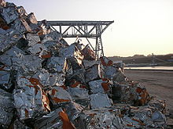](https://en.wikipedia.org/wiki/File:CompactedSteelScraps.jpg)

A pile of compacted steel scraps, ready for recycling

* [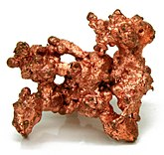](https://en.wikipedia.org/wiki/File:NatCopper.jpg)

[Native copper](https://en.wikipedia.org/wiki/Native_metal#Copper)

* [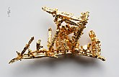](https://en.wikipedia.org/wiki/File:Gold-crystals.jpg)

Gold crystals

* [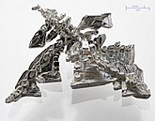](https://en.wikipedia.org/wiki/File:Silver_crystal.jpg)

Crystalline silver

* [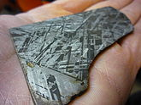](https://en.wikipedia.org/wiki/File:Widmanstatten_hand.jpg)

A slice of meteoric iron

* [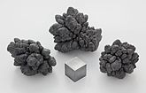](https://en.wikipedia.org/wiki/File:Lead_electrolytic_and_1cm3_cube.jpg)

[oxidised](https://en.wikipedia.org/wiki/Redox) [lead](https://en.wikipedia.org/wiki/Lead)  
nodules and 1 cm3 cube

* [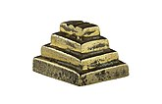](https://en.wikipedia.org/wiki/File:Akan_MHNT.AC.AF.29.jpg)

A brass weight (35 g)

* [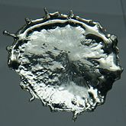](https://en.wikipedia.org/wiki/File:Tin-2.jpg)

A droplet of solidified molten tin

* [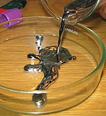](https://en.wikipedia.org/wiki/File:Pouring_liquid_mercury_bionerd.jpg)

[Mercury](https://en.wikipedia.org/wiki/Mercury_(element)) being  
poured into a [petri dish](https://en.wikipedia.org/wiki/Petri_dish" \o "Petri dish)

* [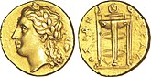](https://en.wikipedia.org/wiki/File:25_litrai_en_%C3%A9lectrum_repr%C3%A9sentant_un_tr%C3%A9pied_delphien.jpg)

Electrum, a natural alloy of silver and gold, was often used for making coins. Shown is the Roman god Apollo, and on the obverse, a Delphi tripod (circa 310–305 BCE).

* [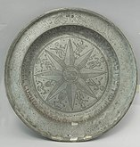](https://en.wikipedia.org/wiki/File:Passover_Plate_(4047010755).jpg)

A plate made of [pewter](https://en.wikipedia.org/wiki/Pewter), an alloy of 85–99% tin and (usually) copper. Pewter was first used around the beginning of the Bronze Age in the Near East.

* [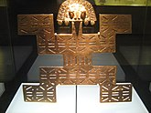](https://en.wikipedia.org/wiki/File:Museo_del_Oro_-_Tolima_pectoral.jpg)

A pectoral (ornamental breastplate) made of [tumbaga](https://en.wikipedia.org/wiki/Tumbaga" \o "Tumbaga), an alloy of gold and copper

* [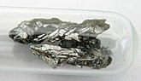](https://en.wikipedia.org/wiki/File:Arsen_1a.jpg)

Arsenic, sealed in a container to prevent tarnishing

* [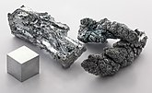](https://en.wikipedia.org/wiki/File:Zinc_fragment_sublimed_and_1cm3_cube.jpg)

Zinc fragments and a 1 cm3 cube

* [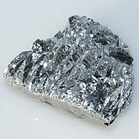](https://en.wikipedia.org/wiki/File:Antimony-4.jpg)

Antimony, showing its brilliant lustre

* [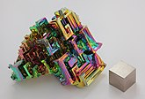](https://en.wikipedia.org/wiki/File:Wismut_Kristall_und_1cm3_Wuerfel.jpg)

Bismuth in crystalline form, with a very thin oxidation layer, and a 1 cm3 bismuth cube

[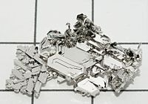](https://en.wikipedia.org/wiki/File:Platinum_crystals.jpg)

Platinum crystal

* [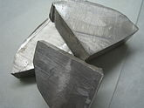](https://en.wikipedia.org/wiki/File:Na_(Sodium).jpg)

Chunks of sodium

* [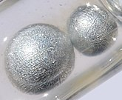](https://en.wikipedia.org/wiki/File:Potassium-2.jpg)

Potassium pearls under paraffin oil. Size of the largest pearl is 0.5 cm.

* [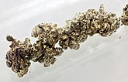](https://en.wikipedia.org/wiki/File:Strontium_destilled_crystals.jpg)

Strontium crystals

* [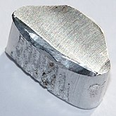](https://en.wikipedia.org/wiki/File:Aluminium-4.jpg)

Aluminium chunk,  
2.6 grams, 1 x 2 cm

* [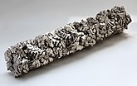](https://en.wikipedia.org/wiki/File:Titan-crystal_bar.JPG)

A bar of titanium crystals

* [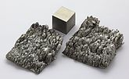](https://en.wikipedia.org/wiki/File:Scandium_sublimed_dendritic_and_1cm3_cube.jpg)

Scandium, including a 1 cm3 cube

Physical Properties of Metals

* All the metals are good conductors of heat and electricity. Cooking utensils and irons are made up of metals as they are good conductors of heat.
* Ductility is the ability of the material to be stretched into a wire. This ability allows metals to be drawn into wires and coupled with their durability, find applications as cable wires and for soldering purposes. Because Metal can be drawn into wires we can say that metals are ductile.
* Malleability is the property of substances which allows them to be beaten into flat sheets. Aluminium sheets are used in the manufacturing of Aircrafts because of their lightweight and strength. Other metal sheets are used in automobile industries, for making utensils, etc. Therefore, metals are malleable.
* Metals are sonorous because they produces a deep or ringing sound when struck with another hard object.
* Usually, all the metals have a shiny appearance but these metals can also be polished to have a shiny appearance.

Chemical properties of Metals

1. **Reaction with water:** Only highly reactive metals react with water and not all the metals. For example, Sodium reacts vigorously with water and oxygen and gives a large amount of heat in the process. This is why sodium is stored in kerosene so that it does not come in contact with moisture or oxygen.
2. **Reaction with acids:** Hydrogen gas is produced when metals react with acids. For example, when zinc reacts with hydrochloric acid it produces zinc chloride and hydrogen gas.
3. **Reaction with bases:**Not all the metals react with bases and when they do react, they produce metal salts and hydrogen gas. When zinc reacts with strong sodium hydroxide it gives sodium zincate and hydrogen gas.
4. **Reaction with oxygen:**Metal oxides are produced when metals burn in the presence of oxygen. These metal oxides are basic in nature. For example: When a magnesium strip is burned in the presence of oxygen it forms [magnesium](https://byjus.com/chemistry/magnesium/) oxide and when magnesium oxide dissolves in water it forms magnesium hydroxide.

Metalloid

A **metalloid** is a type of [chemical element](https://en.wikipedia.org/wiki/Chemical_element) which has a preponderance of [properties](https://en.wikipedia.org/wiki/Material_property) in between, or that are a mixture of, those of [metals](https://en.wikipedia.org/wiki/Metal) and [nonmetals](https://en.wikipedia.org/wiki/Nonmetal). There is no standard definition of a metalloid and no complete agreement on which elements are metalloids. Despite the lack of specificity, the term remains in use in the literature of [chemistry](https://en.wikipedia.org/wiki/Chemistry).

The six commonly recognised metalloids are [boron](https://en.wikipedia.org/wiki/Boron), [silicon](https://en.wikipedia.org/wiki/Silicon), [germanium](https://en.wikipedia.org/wiki/Germanium), [arsenic](https://en.wikipedia.org/wiki/Arsenic), [antimony](https://en.wikipedia.org/wiki/Antimony), and [tellurium](https://en.wikipedia.org/wiki/Tellurium). Five elements are less frequently so classified: [carbon](https://en.wikipedia.org/wiki/Carbon), [aluminium](https://en.wikipedia.org/wiki/Aluminium" \o "Aluminium), [selenium](https://en.wikipedia.org/wiki/Selenium), [polonium](https://en.wikipedia.org/wiki/Polonium), and [astatine](https://en.wikipedia.org/wiki/Astatine). On a standard periodic table, all eleven elements are in a diagonal region of the [p-block](https://en.wikipedia.org/wiki/P-block) extending from boron at the upper left to astatine at lower right. Some periodic tables include a [dividing line between metals and nonmetals](https://en.wikipedia.org/wiki/Dividing_line_between_metals_and_nonmetals), and the metalloids may be found close to this line.

Typical metalloids have a metallic appearance, but they are brittle and only fair [conductors of electricity](https://en.wikipedia.org/wiki/Electrical_conductor). Chemically, they behave mostly as nonmetals. They can form [alloys](https://en.wikipedia.org/wiki/Alloy) with metals. Most of their other [physical properties](https://en.wikipedia.org/wiki/Physical_property) and [chemical properties](https://en.wikipedia.org/wiki/Chemical_property) are intermediate in nature. Metalloids are usually too brittle to have any structural uses. They and their compounds are used in alloys, biological agents, [catalysts](https://en.wikipedia.org/wiki/Catalyst), [flame retardants](https://en.wikipedia.org/wiki/Flame_retardant), [glasses](https://en.wikipedia.org/wiki/Glass), [optical storage](https://en.wikipedia.org/wiki/Optical_storage) and [optoelectronics](https://en.wikipedia.org/wiki/Optoelectronics), [pyrotechnics](https://en.wikipedia.org/wiki/Pyrotechnics), [semiconductors](https://en.wikipedia.org/wiki/Semiconductor), and electronics.

The electrical properties of silicon and germanium enabled the establishment of the [semiconductor industry](https://en.wikipedia.org/wiki/Semiconductor_industry) in the 1950s and the development of [solid-state electronics](https://en.wikipedia.org/wiki/Solid-state_electronics) from the early 1960s.[[1]](https://en.wikipedia.org/wiki/Metalloid#cite_note-2)

The term *metalloid* originally referred to nonmetals. Its more recent meaning, as a category of elements with intermediate or hybrid properties, became widespread in 1940–1960. Metalloids are sometimes called semimetals, a practice that has been discouraged,[[2]](https://en.wikipedia.org/wiki/Metalloid" \l "cite_note-Atkins2010p20-3) as the term [*semimetal*](https://en.wikipedia.org/wiki/Semimetal) has a different meaning in [physics](https://en.wikipedia.org/wiki/Physics) than in chemistry. In physics, it refers to a specific kind of [electronic band structure](https://en.wikipedia.org/wiki/Electronic_band_structure) of a substance. In this context, only arsenic and antimony are semimetals, and commonly recognised as metalloids.

Examples

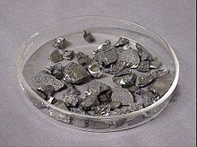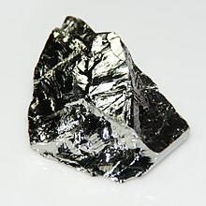  
  
  
  
  
  
  
  
  
  
germanium boron

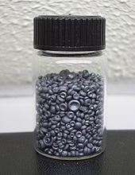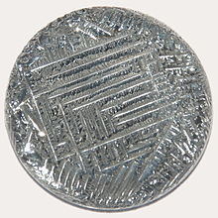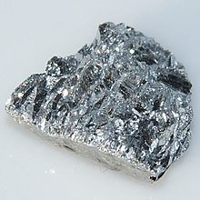  
  
  
  
  
  
  
  
  
  
  
  
 antimony tellurium

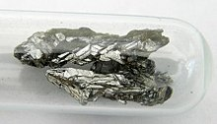

arsenic

selenium

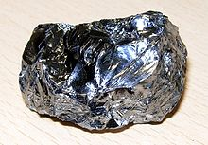  
  
 silicon iodine

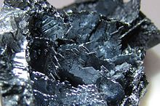

General Properties of Metalloids

* Metalloids typically look like metals. However, these elements often behave like non-metals.
* Physically, metalloids are brittle, somewhat shiny substances that are usually solid at ambient temperatures.
* These elements usually have intermediate to fairly strong electrical conductivity
* Metalloids are known to have electronic band structures that are similar to semimetals or semiconductors.
* Chemically, these elements usually act as non-metals (in a relatively weak manner)
* These elements generally have intermediate energies of ionisation and values of electronegativity
* Metalloids are known to form amphoteric or weakly acidic oxides.
* These elements have the ability to form metallic alloys.
* Many of the other physical and chemical properties of metalloids, in essence, are intermediate.

Applications of Metalloids

Metalloids and the compounds of metalloids are widely used as alloys (or in the production of alloys as a component of the mixture), biological agents (which can be nutritional, toxicological, and medicinal as well), flame retardants, catalysts, glasses (which can be oxides or metallic in nature), and optical storage media. Metalloids are also known to have applications in optoelectronics, semiconductors, pyrotechnics, and electronics.

Alloys formed when combined with transition metals are extremely well-represented when it comes to the lighter metalloids. Boron has the ability to form intermetallic compounds. This element also has the ability to form alloys with these MnB composition metals if the value of n is greater than 2. In fact, ferroboron (which contains 15 per cent boron) is widely used in order to inject boron into steel. Furthermore, nickel-boron alloys are used as ingredients in the engineering industry for welding alloys and case hardening compositions.

Silicon alloys of aluminium and iron are widely used in the construction and automotive industries. Germanium is known to form several alloys, especially the coinage metals in particular.

Medical Applications of Metalloids

Each and every one of the six elements that are widely known as metalloids are known to be either toxic, or to have medicinal and nutritional properties. For example, compounds of antimony and arsenic are known to be especially toxic. However, boron, arsenic, and silicon are extremely important trace elements.The four elements boron, arsenic, silicon, and antimony are known to have many medical uses. The remaining two elements (germanium and tellurium) are known to have great potential for medicinal applications.

Furthermore, [boron](https://byjus.com/chemistry/boron/) is used in herbicides and also in insecticides. This element is an active trace element, which has several antiseptic, antiviral, and antifungal properties in the form of boric acid.

Non metals

Non-metals are those which lack all the metallic attributes. They are good insulators of heat and electricity. They are mostly gases and sometimes liquid. Some of then are even solid at room temperature like Carbon, [sulphur](https://byjus.com/chemistry/sulfur/) and phosphorus.

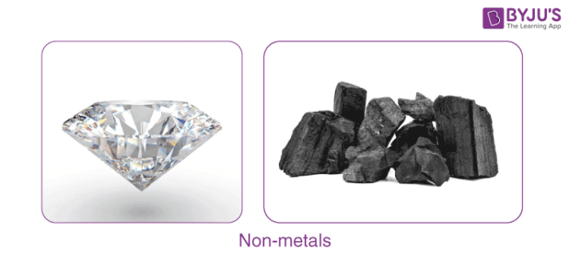

Properties of Non metals

Characteristic properties of non-metals are high ionization energies and high [electronegativity](https://byjus.com/chemistry/electronegativity/). Owing to these properties, non-metals usually gain electrons when react with other compounds, forming covalent bonds.

The following are the general properties of non-metals.

The atoms of non-metals tend to be smaller than those of metals. Several of the other properties of non-metals result from their atomic sizes.

Non-metals have high electronegativities. This means that the atoms of non-metals have a strong tendency to attract more electrons than what they would normally have.

Non-metals have high electronegativities. This means that the atoms of non-metals have a strong tendency to hold on to the electrons that already have. In contrast, metals rather easily give up one or more electrons to non-metals, metal therefore easily form positively charged ions, and metals readily conduct electricity.

Physical Properties of Non-Metals

Under normal conditions of temperature and pressure, some non-metals are found as gases, some found as solids and one is found as liquid. In contrast, except mercury, all metals are solids at room temperature. The fact that so many non-metals exist as liquids or gases means that non-metals generally have relatively low melting and boiling points under normal atmospheric conditions.

In their solid-state, non-metals tend to be brittle. Therefore, they lack the malleability and ductility exhibited by metals.

Ductility is the property of the material to be stretched into wires but non-metals are not ductile except for carbon, as carbon fibres find uses in a wide variety of industries including sports and music equipment.

Another property characteristic to metals is absent in non-metals called malleability. They can’t be drawn into sheets as they are brittle and break on applying pressure.

Non-metals exhibit very low electrical conductivities. The low or non-existent electrical conductivity is the most important property that distinguishes non-metals from metals.

They are not sonorous and do not produce a deep ringing sound when they are hit with another material. They are also bad conductors of heat and electricity except for [graphite](https://byjus.com/chemistry/graphite/).

List of Non-Metals (the Complete List)

|  |  |  |
| --- | --- | --- |
| **Non-metal** | **State at Room Temperature** | **Symbol** |
| Hydrogen | Gas | H |
| Nitrogen | Gas | N |
| Oxygen | Gas | O |
| Fluorine | Gas | F |
| Chlorine | Gas | Cl |
| Bromine | Liquid | Br |
| Iodine | Solid | I |
| Carbon | Solid | C |
| Sulphur | Solid | S |
| Phosphorous | Solid | P |
| Silicon | Solid | Si |

Chemical Properties of Non-Metals

### 1. Reaction with Water

A non-metal does not react with water but it is usually very reactive in air, which is why some of them are stored in water. For example, one of the highly reactive non-metals is phosphorus and it catches fire when exposed to air that is why it is stored in water to prevent its contact with atmospheric oxygen.

### 2. Reaction with Acids

None of the non-metals is known to react with acids.

### 3. Reaction with Bases

The reaction between non-metals and bases is a very complex one. The reaction of chlorine with bases like sodium hydroxide gives products like sodium hypochlorite, [sodium chloride](https://byjus.com/chemistry/preparation-properties-and-uses-of-sodium-chloride/) as well as water.

### 4. Reaction with Oxygen

Oxides of non-metals are formed when it reacts with oxygen. The oxides of non-metals are acidic or neutral in nature.

When sulphur reacts with oxygen, we get sulphur dioxide.

***S     +      O2      →       SO2***

When sulphur dioxide reacts with water it forms sulphurous acid.

***SO2    +      H2O      →     H2SO3***

### 5. Reaction with metal

Non-Metals react with metal, generally forming Ionic compounds.

**Na+ + Cl– → NaCl**